Truth and Ethics

Source: https://people.ischool.berkeley.edu/~dbamman/nlp20_slides/5_truth_ethics.pdf

Annotated datasets
- Penn Treebank: WSJ articles
- SquAD: annotates questions and answers in Wikipedia

Adjudication
- Decide on ground truth annotation from multiple independent annotations
- Interannotator agreement:
  - Cohen’s kappa: (can get high agreement by chance if classes are imbalanced)
  - Fleiss’ kappa: calculate agreement for multiple pairs of annotators

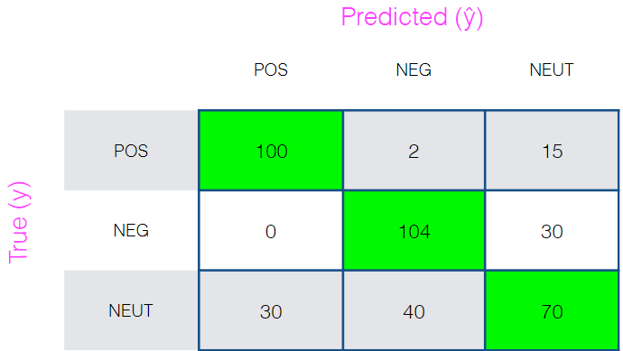
Evaluation
- Confusion matrix
- Accuracy:
- Precision:
- Recall:
- F1:

Hypothesis testing
- Check statistical significance of result
- Parametric/non-parametric

Limitations
- Performance may not be equal across domains (news → novels)
- Choice of metrics will influence design

